Case Study No.: 6
Title: To perform various string operation using javascript:
a) to perform basics of string
b) work with strings: substring(), indexOf(), split(), replace().
Write a program to reverse a string.WAP to count the number of vowels in a paragraph
Software/Tools Required: HTML5, CSS3, JavaScript, VS Code, Google Chrome
Index.html:
<!DOCTYPE html>
<html lang="en">
<head>
<meta charset="UTF-8">
<meta name="viewport" content="width=device-width, initial-scale=1.0">
<title>JavaScript String Operations</title>
<link rel="stylesheet" href="style.css">
</head>
<body>
<div class="container">
<header>
<h1>JavaScript String Operations</h1>
<p>Explore and perform different string operations</p>
</header>
<section class="card">
<h2>Basic String Operations</h2>
<input
type="text"
id="basicString"
placeholder="Enter a string"
>
<button onclick="performBasicOperations()">
Perform Operations
</button>
<div id="basicResult" class="result"></div>
</section>
<section class="card">
<h2>Reverse a String</h2>
<input
type="text"
id="reverseInput"
placeholder="Enter a string to reverse"
>
<button onclick="reverseString()">
Reverse String
</button>
<div id="reverseResult" class="result"></div>
</section>
<section class="card">
<h2>Count Vowels in a Paragraph</h2>
<textarea
id="paragraphInput"
placeholder="Enter a paragraph here..."
></textarea>
<button onclick="countVowels()">
Count Vowels
</button>
<div id="vowelResult" class="result"></div>
</section>
<footer>
<p>Shruti Bawankar 24070521148</p>
</footer>
</div>
<script src="script.js"></script>
</body>
</html>
Script.js:
function performBasicOperations() {
let str = document.getElementById("basicString").value;
let result = document.getElementById("basicResult");
if (str.trim() === "") {
result.style.display = "block";
result.innerHTML = "⚠️ Please enter a string.";
return;
}
let substring = str.substring(0, 5);
let position = str.indexOf("JavaScript");
let words = str.split(" ");
let replaced = str.replace("JavaScript", "World");
result.style.display = "block";
result.innerHTML = `
<strong>Original String:</strong> ${str}<br>
<strong>Length:</strong> ${str.length}<br>
<strong>Uppercase:</strong> ${str.toUpperCase()}<br>
<strong>Lowercase:</strong> ${str.toLowerCase()}<br>
<strong>substring(0, 5):</strong> ${substring}<br>
<strong>indexOf("JavaScript"):</strong> ${position}<br>
<strong>split(" "):</strong> ${words.join(" | ")}<br>
<strong>replace():</strong> ${replaced}
`;
}
function reverseString() {
let str = document.getElementById("reverseInput").value;
let result = document.getElementById("reverseResult");
if (str.trim() === "") {
result.style.display = "block";
result.innerHTML = "⚠️ Please enter a string.";
return;
}
let reversed = str.split("").reverse().join("");
result.style.display = "block";
result.innerHTML = `
<strong>Original String:</strong> ${str}<br>
<strong>Reversed String:</strong> ${reversed}
`;
}
function countVowels() {
let paragraph = document.getElementById("paragraphInput").value;
let result = document.getElementById("vowelResult");
if (paragraph.trim() === "") {
result.style.display = "block";
result.innerHTML = "⚠️ Please enter a paragraph.";
return;
}
let count = 0;
for (let character of paragraph.toLowerCase()) {
if ("aeiou".includes(character)) {
count++;
}
}
result.style.display = "block";
result.innerHTML = `
<strong>Number of vowels:</strong> ${count} 🎉
`;
}
Style.css:
* {
margin: 0;
padding: 0;
box-sizing: border-box;
}
body {
font-family: Georgia, sans-serif;
background: url("images/background.png") no-repeat center center fixed;
background-size: cover;
min-height: 100vh;
padding: 40px 20px;
color: #333;
}
.container {
max-width: 900px;
margin: auto;
}
header {
text-align: center;
color: rgb(21, 20, 20);
margin-bottom: 30px;
}
header h1 {
font-size: 36px;
margin-bottom: 10px;
}
header p {
font-size: 17px;
opacity: 0.9;
}
.card {
background: white;
padding: 25px;
margin-bottom: 25px;
border-radius: 15px;
box-shadow: 0 10px 25px rgba(0, 0, 0, 0.15);
}
.card h2 {
margin-bottom: 20px;
color: #0a0b0b;
}
input,
textarea {
width: 100%;
padding: 14px;
border: 2px solid #ddd;
border-radius: 8px;
font-size: 16px;
margin-bottom: 15px;
outline: none;
transition: 0.3s;
}
input:focus,
textarea:focus {
border-color: #667eea;
}
textarea {
height: 130px;
resize: vertical;
}
button {
background: linear-gradient(135deg, #667eea, #5367ae);
color: white;
border: none;
padding: 12px 22px;
border-radius: 8px;
font-size: 16px;
cursor: pointer;
transition: 0.3s;
}
button:hover {
transform: translateY(-2px);
box-shadow: 0 5px 15px rgba(102, 126, 234, 0.4);
}
.result {
margin-top: 20px;
padding: 18px;
background: #f5f6ff;
border-left: 5px solid #667eea;
border-radius: 8px;
line-height: 1.8;
display: none;
}
.result strong {
color: #5a4fcf;
}
footer {
text-align: center;
color: white;
margin-top: 30px;
font-size: 14px;
}
@media (max-width: 600px) {
body {
padding: 20px 10px;
}
header h1 {
font-size: 28px;
}
.card {
padding: 20px;
}
}

Output:

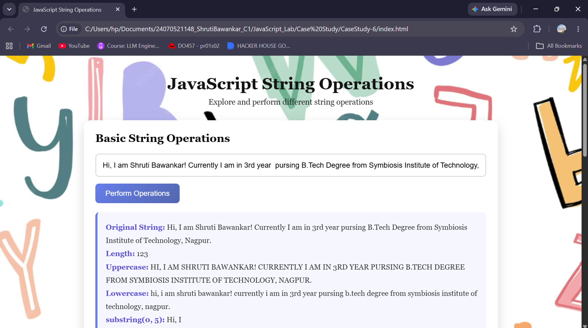
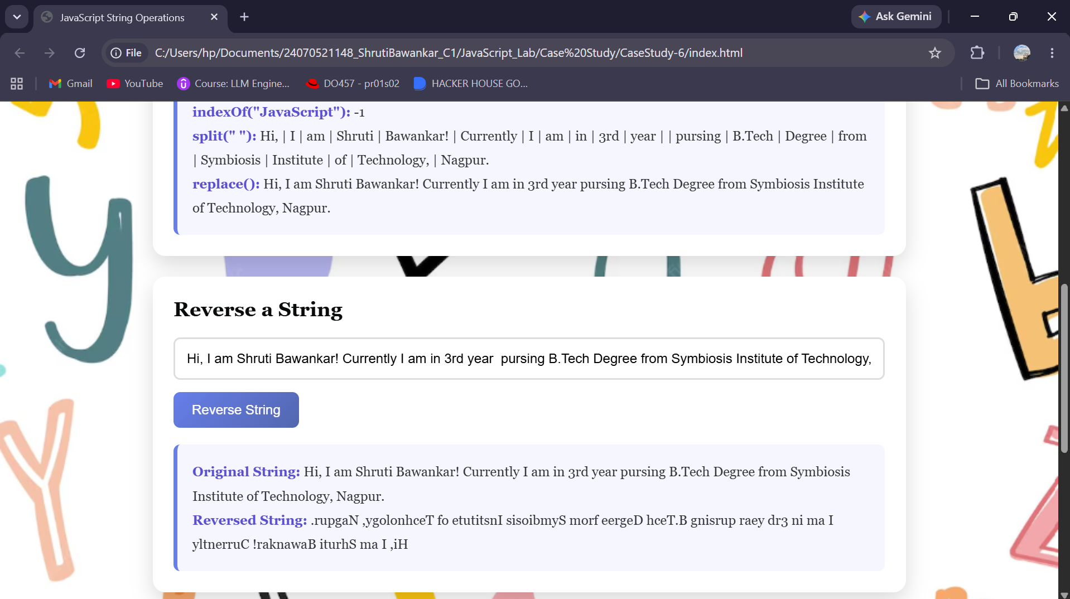
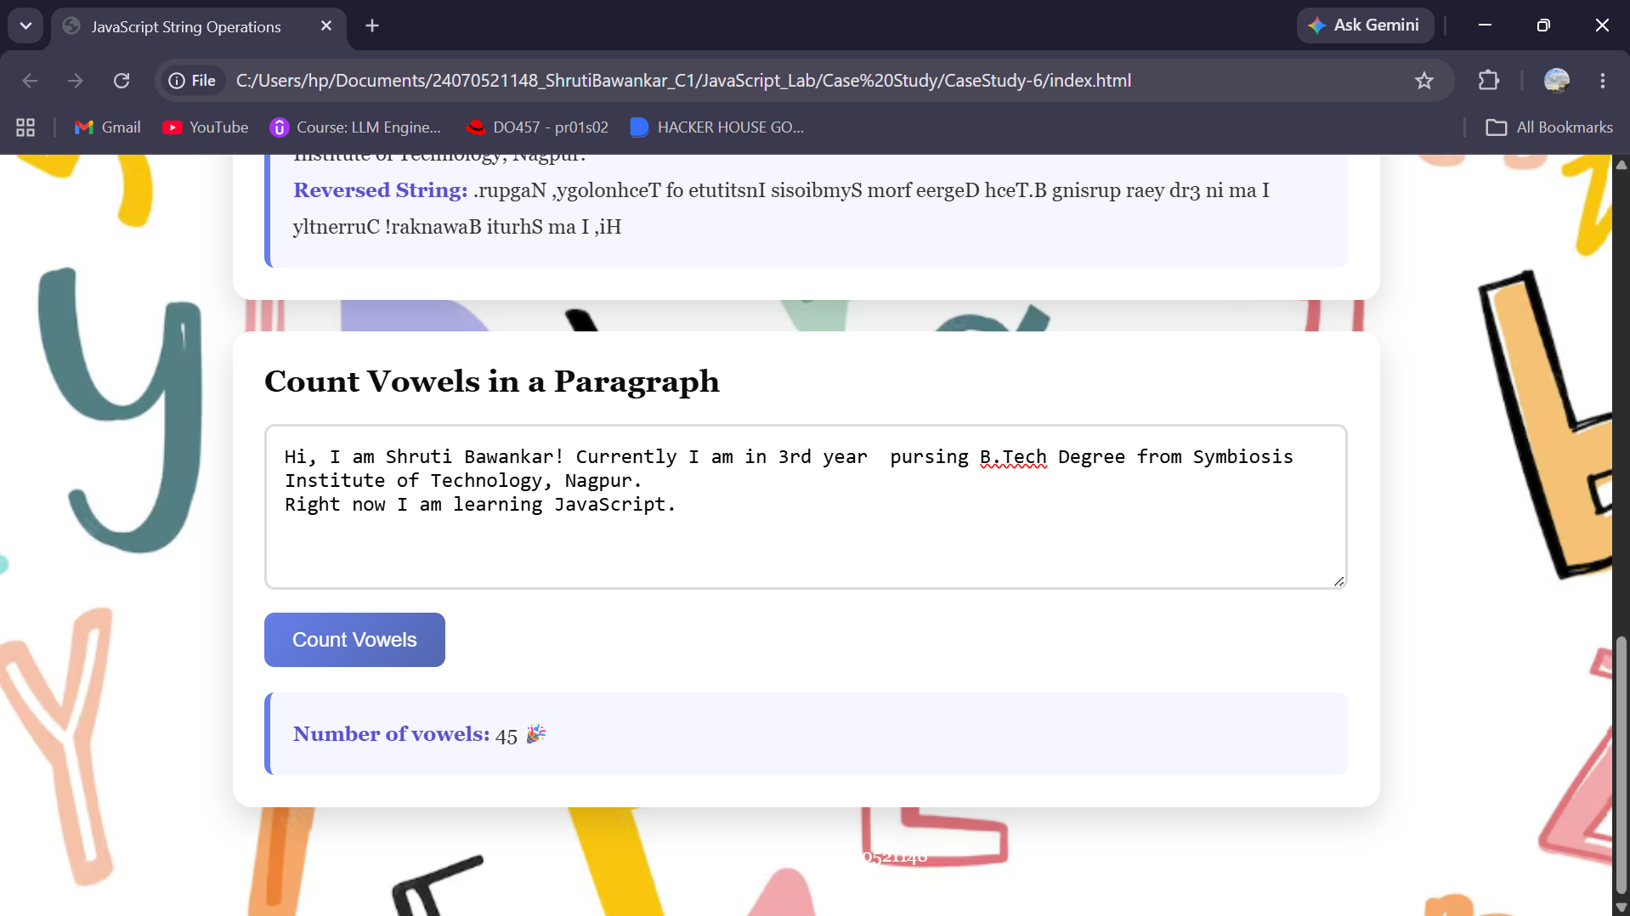

Result: Successfully performed various string operations using JavaScript, including substring(), indexOf(), split(), replace(), string reversal, and vowel counting.
Conclusion: Thus, JavaScript string manipulation methods were successfully implemented to process and analyze strings efficiently.

